Invitation
2016 Nordic Championships - Bornholm - Denmark
9-11 September 2016
Date: 02-08-2016

Dear Friends,

Modern Pentathlon Denmark hereby invites you to participate in the Nordic Championships 2016 to be held at the Danish Baltic island Bornholm.
As always, we try to make this a special experience for all participants and accompanying per- sons. Families and friends are very welcome.

Programme:
Friday 9 SEP
Arrival of Delegations
20:00 Equipment control shooting and fencing
21:00 Technical Meeting

Saturday 10 SEP
07:30 – 08:30 Swimming
09:30 – 12:00 Fencing
12:00 – 13:00 Lunch
13:00 – 15:00 Riding
16:30 – 17:30 Combined Event

Sunday 11 SEP
Breakfast and departure,
potentially sightseeing and sea-bathing
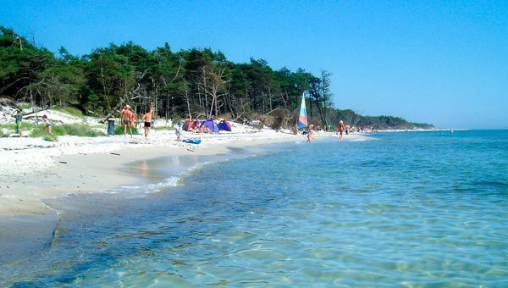

MODERNE FEMKAMP DANMARK
info@femkamp.dk - www.femkamp.dk - Nordea 2348 0310 034 477 - IBAN DK3420000310034477 - SWIFT/BIC NDEADKKK

2016 Nordic Championships - Bornholm - Denmark 9-11 September 2016
Entry Form “C” (final)
Return no later than 23 August 2016

No. | Last name | First name | Function | Arrival  date | Arrival  time | Flight no./  transport | Departure  date | Departure  time | Flight no./  transport | Room type  (2,4,6 p) | Room  partner | Age  group | UIPM  License

Signature: ............................................ Name printed ................................ Date: ...............................

Return by e-mail to belmann3@gmail.com. Contact phone: +45 3074 4599.

MODERNE FEMKAMP DANMARK
info@femkamp.dk - www.femkamp.dk - Nordea 2348 0310 034 477 - IBAN DK3420000310034477 - SWIFT/BIC NDEADKKK

FINANCIAL CONDITIONS
Participation fee will be € 120 per person total, full board from Friday 19:00 till Sunday 12:00. All participants will be accommodated at Danhostel Svaneke.

ENTRY FORM
We would appreciate early confirmation of your participation and submit this as Entry Form as follows:

Form C 23 August 2016

ATHLETES’ LICENSES
Pentathletes without confirmation from their NF of their ability to ride can compete in Nordic
Open Championships in 4 disciplines apart from riding. Athletes wanting to participate in 4
disciplines, without riding, are very welcome to take part.
In addition, the Jury will have the authority to eliminate a rider during warming up, should it be- come evident that the rider is not in possession of proper riding skills.

Practical information.

Swimming in 25m, 6 lane pool
Running on grass and synthetic material surface. Spikes will be relevant.
Combined Event on 10 position shooting stand. Heat-allocation after ranking. Best heat first.

Transport:
- You can fly to Bornholm Airport via Copenhagen, with DAT, link www.dat.dk
- You can travel by fast catamaran ferry from Ystad, Sweden. Travel time 1h20min. www.faergen.dk
Note: Catamaran ferries are HF Leonora Christina or HF Villum Clausen only.

For booking support, please do not hesitate to ask our help and advice.
Travel by ferry allows, as an example, 5 passengers per car free of charge. For arrival by plane we will pick you up in the airport.
The island is approximately 20 by 30 km large, to give you an idea of distances, and has excellent infrastructure, an airport and, and its own hospital.

Come earlier and stay longer:
We offer those who are interested to set up tents on our land before and after the competition free of charge. We have bathing facilities available. We are willing to arrange for food etc. after specific agreement, between 7 and 12 September.

Registration:

Preliminary registration as soon as possible, until 15 August
Final registration not later than 26 August
We will probably be able to accommodate a few more even after that time, as an exception.

TRAINING
The CE competition venue is located on the coast with grass surface and terrain in the immediate vicinity. Good running terrain and swimming options in the sea are found in immediate vicinity to the accommodation.

EQUIPMENT CONTROL
The equipment control for fencing and shooting will take place Friday night.

TRANSPORTATION PLAN
Transportation from the airport to the accommodation (30 km distance) will be arranged upon request and clear indication of arrival times not later than 1 week prior to the competition. Transportation to and from the competition venues will be arranged after necessity.

Benny Elmann-Larsen
President
Modern Pentathlon Denmark

